Table of Contents
Set-up Instructions for My HuTerra 1
Earning HuTerra Rewards 8
Earning HuTerra Rewards with Local Stores 8
Earning HuTerra Rewards by Shopping Online 13
Tracking Your Receipts 14
History of Giving 16

Set-up Instructions for My HuTerra
- Your first step should be to download the “My HuTerra” app.

- Once downloaded, you’ll create your account by providing the following pieces of information: First name, last name, zip code, username, email, and password. You’ll be asked to read and accept the terms of use. Once you’ve completed each of these items, you’ll click the “Sign Up” button.
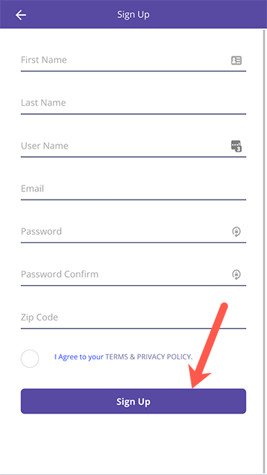

- Now it’s time to select your fundraiser so you can start earning rewards for your favorite cause! You can get there one of two ways:
  - Tap the menu in the upper, left-hand corner of the home screen then tap "My Fundraisers".
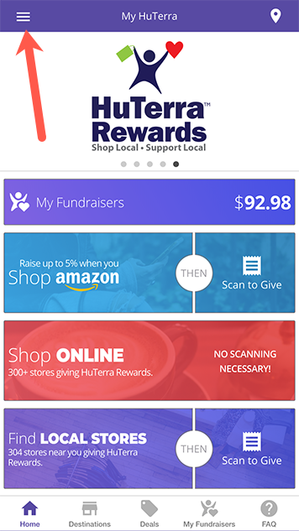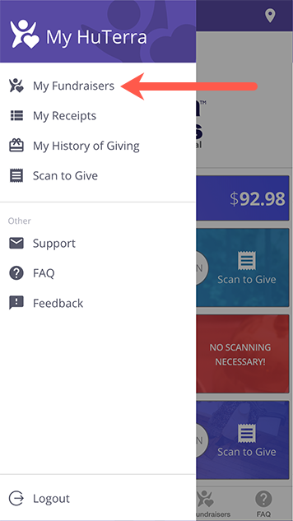

  - Tap the "My Fundraisers" button at the bottom of the home screen.
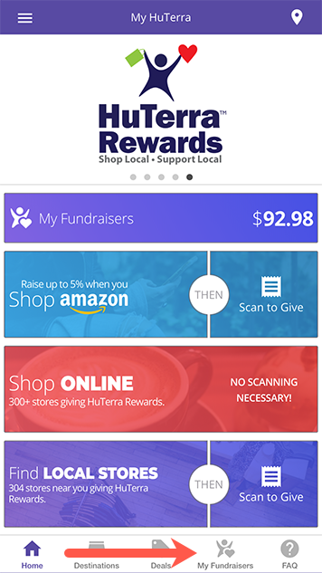

- Tap "Add Fundraiser".
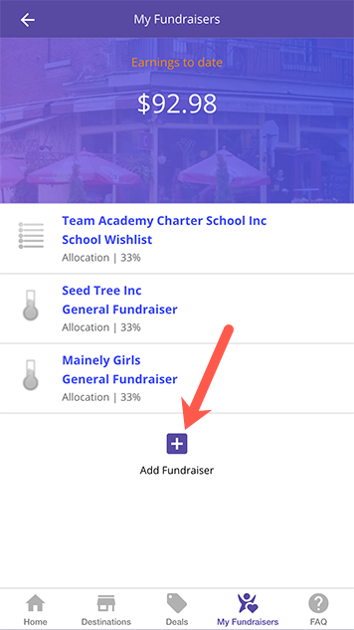

- The My Fundraiser Search Page will open, which will allow you to find and select your fundraiser by typing in [insert nonprofit community name] and tapping return.
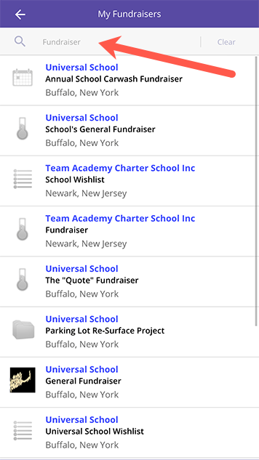

- Select your chosen fundraiser from the list.
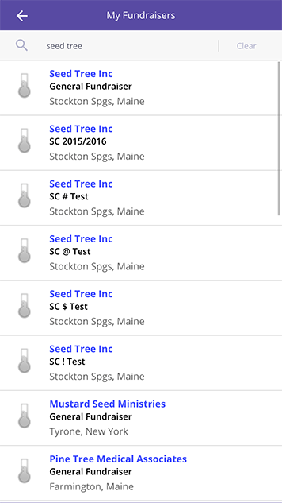
  - If you have a team fundraiser, you’ll then select the team and/or individual team member you are raising funds for from the list provided.
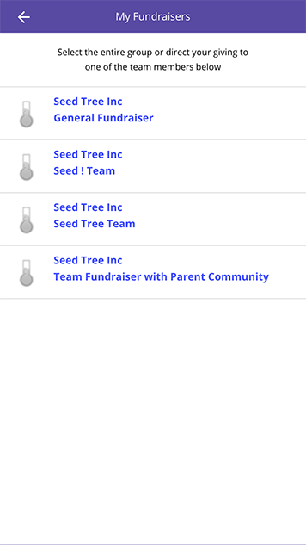
- Congrats! You are now ready to start shopping and RaisingUp HuTerra Rewards for your cause!

Earning HuTerra Rewards

Earning HuTerra Rewards with Local Stores
- From the homepage, you can find local businesses giving rewards by tapping the left-hand side "Find Local Stores" card at the bottom of the screen.
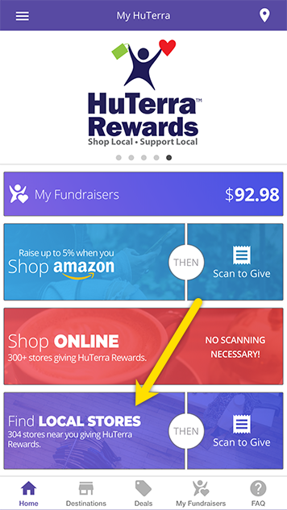

- A list of businesses will be displayed. The list is displayed by distance based on your current location. You can either browse the current list shown or search for a specific business by selecting the search bar at the top of the screen and entering your search criteria on the “HuTerra Reward Search Page” and tapping return once you’ve entered your criteria. You can also display a map of your area by pressing the map icon in the upper right-hand corner of the list page.
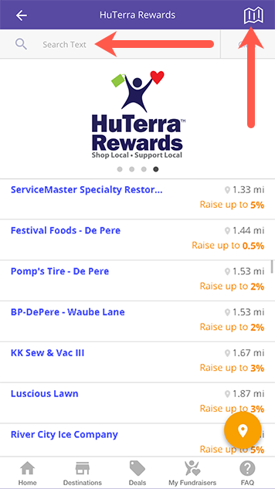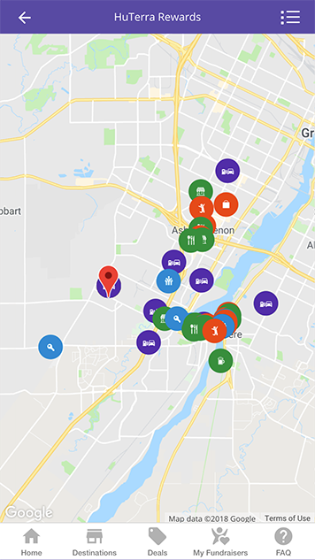

- Once you’ve finished shopping, it’s time to scan (take a picture) of your receipt. You’ll start by selecting the business from the HuTerra Rewards List page. From there, you’ll be taken to the business detail page where you’ll press the “Scan to Give” button. From there, you’ll enter the amount of your purchase and scan (take a photo or choose an existing photo) your receipt. HuTerra verifies your purchase and adds the HuTerra Rewards earned to your account.
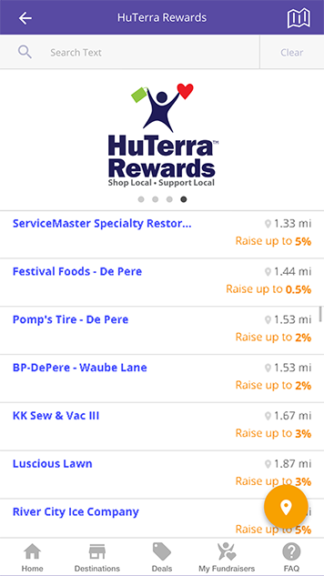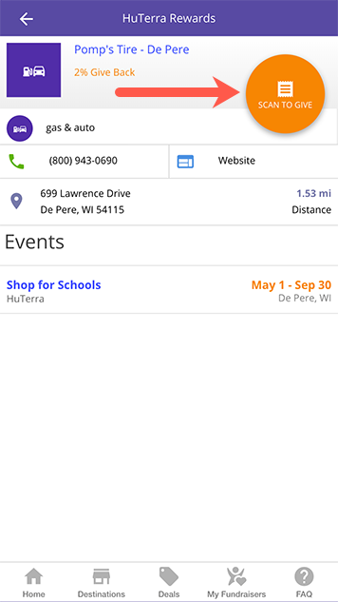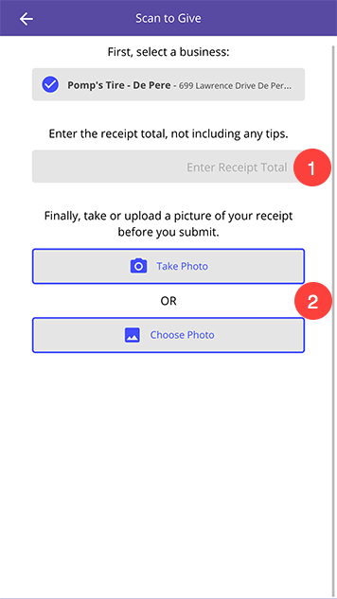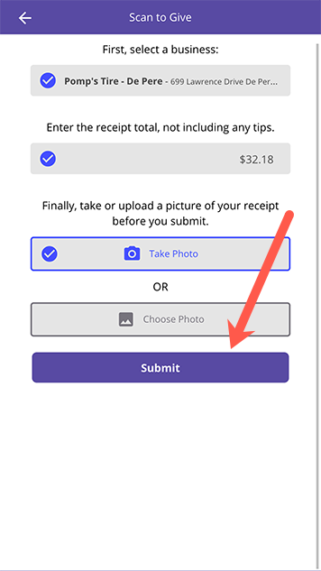

  - Hint: For longer receipts, fold them over in the middle so that the business name, address, date/timestamp and total are still visible when scanned.
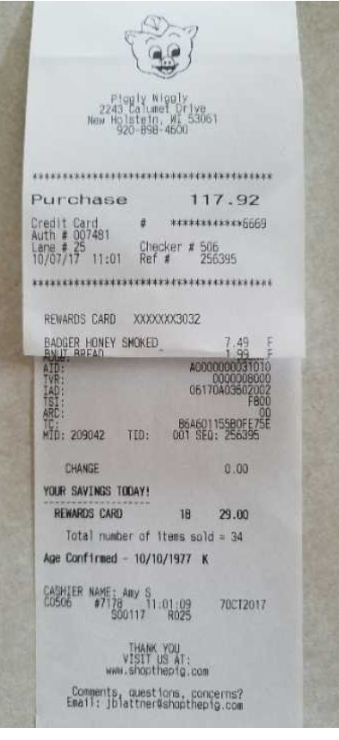

Earning HuTerra Rewards by Shopping Online
- From the homepage, tap on "Shop Online". It will take you to the shopping page in RaiseUp.
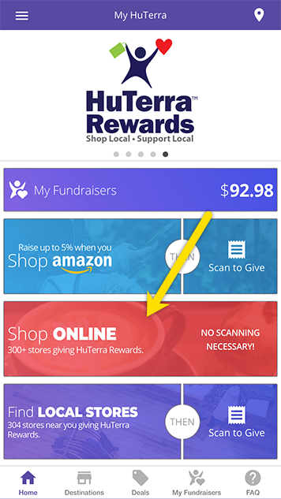
- Scroll down and tap any store you'd like to shop at. By default, the most popular stores are shown, but you can also view all stores, filter by category, and search for a specific store.
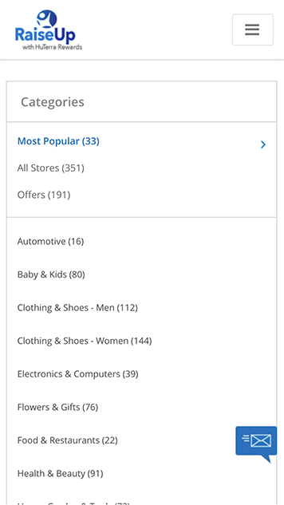 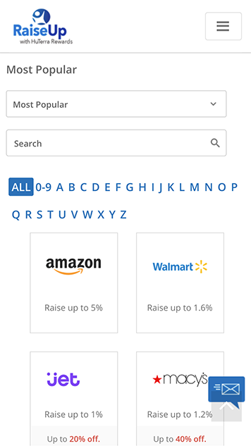
- Shop as you normally would.
- That's it! Any HuTerra rewards earned will be automatically added to your account.

Tracking Your Receipts
- All your receipts are stored within the app. To access any previously submitted receipt from the Home screen, you’ll open the menu (found in the upper, left-hand corner of the app) and select “My Receipts”. To see the scan (picture) of the receipt, just tap the line item.
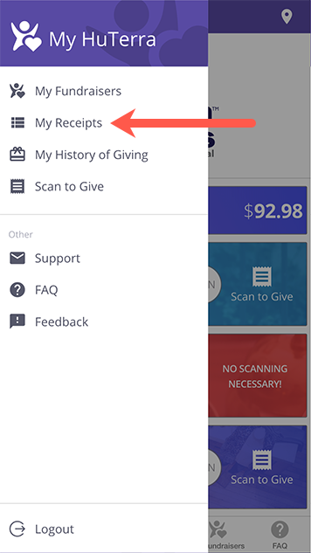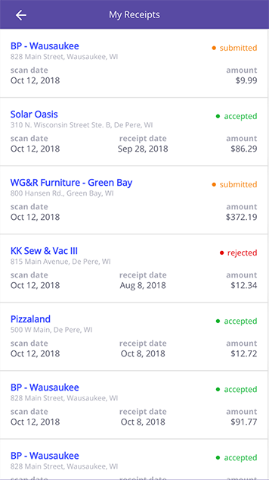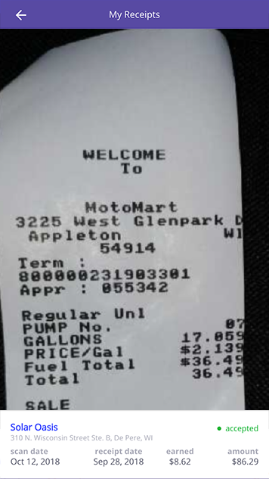

History of Giving
All of your earnings-to-date are tracked within the app. Those can be found within the My History of Giving section of the app. Here you’ll find your overall earnings to date, as well as a break out per fundraiser. Note: You can have up to 5 fundraisers selected at one time.

- Select the menu in the upper, left-hand corner of the app. Tap, “My History of Giving”. This will bring you to the History of Giving Details Page where you’ll find your earnings-to-date for all your fundraisers combined, as well as a break out, per fundraiser.
