General Information:
- Effective July 18, 2019 your statements will be available by month (also known as Period).
- Each requested report will be emailed to you within minutes of your request.
- Each months Statements will be available within 15 days of the end of each month and will remain available for 2 years.
- Your payments will be mailed within 60 days of the end of a given month.

Reports Available Monthly
- Community Rewards Summary – Lists the following data by fundraiser with a total for the community:
  - Opening Balance – the ending balance from the previous month.
  - (month) Activity – the HuTerra Rewards earned for the reported month.
  - Payment – payments made by HuTerra since your last statement. Since HuTerra pays HuTerra Rewards earned in a given month 60-Day after the end of the month the Payment column on June’s report would be for April’s Activity.
  - Ending Balance – your remaining unpaid balance (Opening Balance + Activity – Payments = Ending Balance)
  - Next Payment – the scheduled next payment. June’s report will show the payment that will be mailed by the end of July which would be for May’s Activity.
- Fundraiser Rewards Summary – Same as the Community Rewards Summary report but just for one fundraiser.
- Rewards by Team - Available only if your fundraiser is setup by Team Member and lists the HuTerra Rewards earned by Team Member and all their supporters.
- Rewards by Member - Lists the rewards earned by member.
- Rewards by Business - Lists the rewards earned by business.
- Current Members - Lists all the members that are currently supporting your Fundraiser.

Instructions for accessing your My HuTerra Statements:

If you haven’t already download the My HuTerra app and setup your Account
- Your first step should be to download the “My HuTerra” app.

- Once downloaded, create your account by providing the following pieces of information: First name, last name, zip code, username, email, and password. You’ll be asked to read and accept the terms of use.

If this is the first time you are accessing your statements and you didn’t just setup your account logout and login again.

- Tap the "Menu" button at the top of the Home Page, tap Logout at the bottom of the Menu and then log back in again.

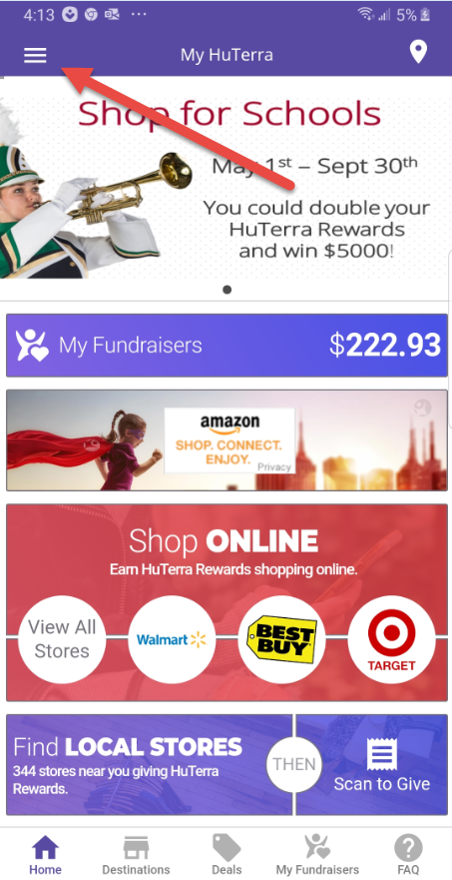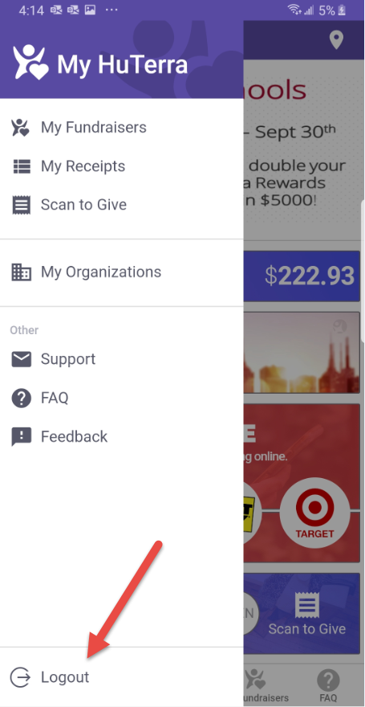

You are now ready to access your HuTerra Rewards Statements.

- Tap the "Menu" button at the top of the Home Page, tap Logout at the bottom of the Menu and then log back in again. You should see “My Organizations” in the menu, if not contact customercare@huterra.com .

- Tap “My Organizations” the list of fundraiser you have access to will be displayed.
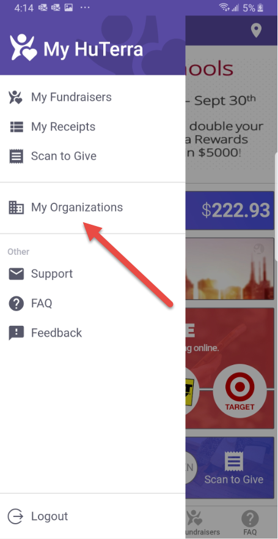

- Find the fundraiser you wish to request the reports for and Tap the “” and then tap the “Reports” option. If all your fundraisers are not available, please contact customercare@huterra.com .

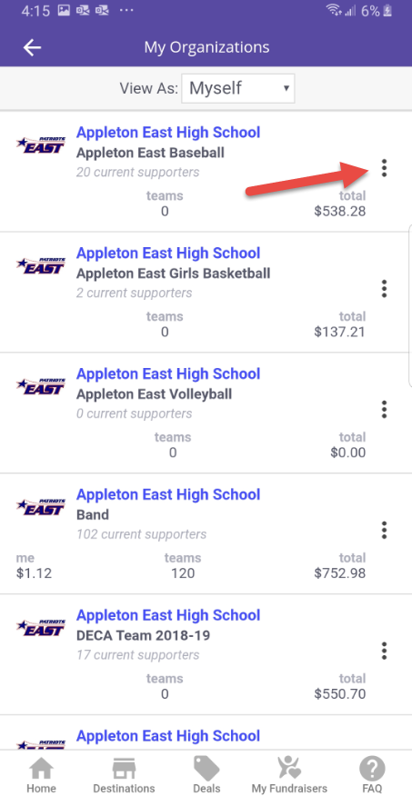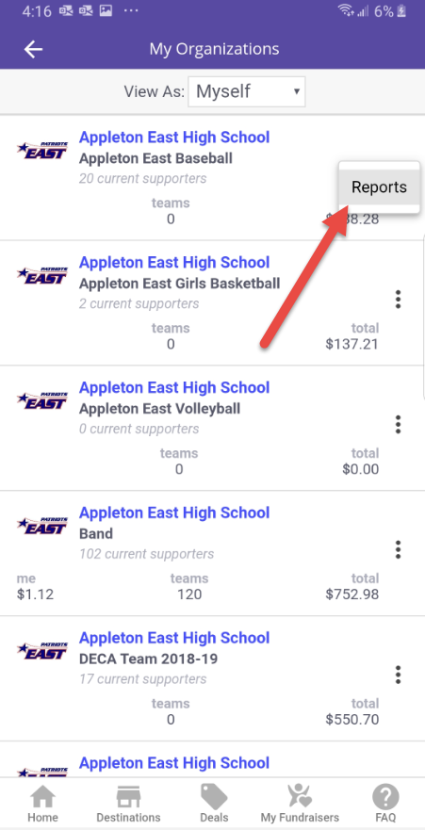

- The My Reports page will open, tap on “Select Period” and then tap the period you wish to request reports for. If the period you are looking for is not available, please contact customercare@huterra.com .

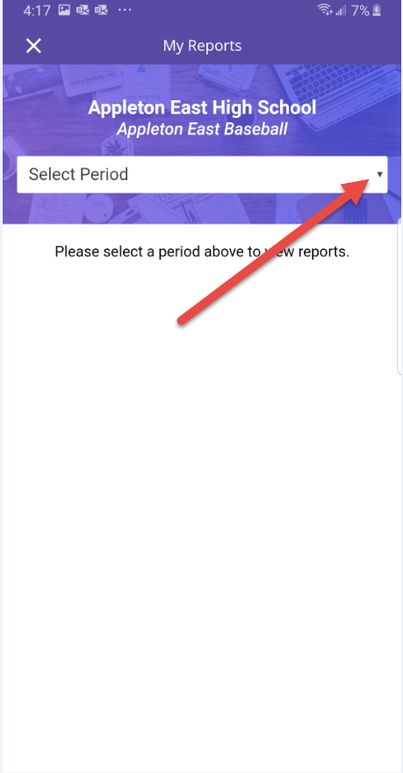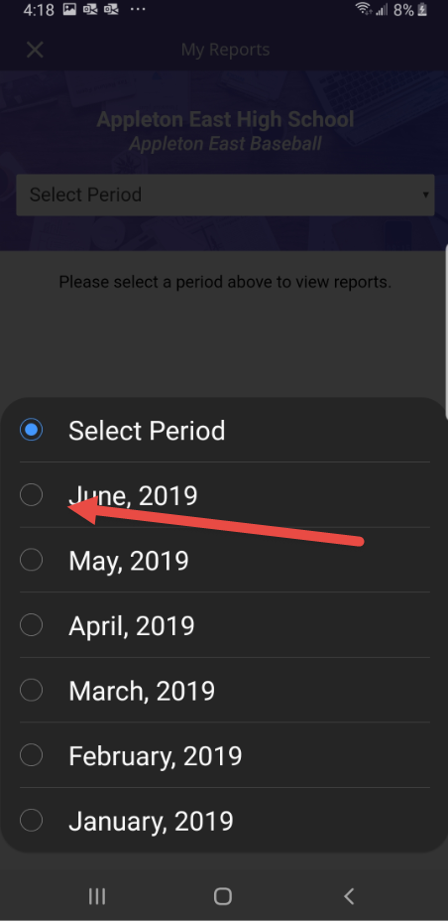

- The “My Reports” request report page for the requested period will open. Select the report(s) you wish and tap “Email Reports”. The reports will be emailed to you within minutes. If you do not receive the email please check your junk or spam folders. If you still didn’t receive the reports, please contact customercare@huterra.com .

